- Create a Sequential model for classifying MNIST digits with the following architecture: Flatten input layer for shape (28,28), Dense layer with 128 neurons and ReLU activation, Dropout layer with rate 0.3, Dense output layer with 10 neurons and softmax activation. Compile the model using Adam optimizer and categorical crossentropy loss.

import tensorflow as tf
from tensorflow.keras.models import Sequential
from tensorflow.keras.layers import Flatten, Dense, Dropout

# Define the Sequential model
model = Sequential([
Flatten(input_shape=(28, 28)), # Flatten layer for 28x28 images
Dense(128, activation='relu'), # Dense hidden layer with 128 neurons and ReLU
Dropout(0.3), # Dropout layer with rate 0.3
Dense(10, activation='softmax') # Output layer with 10 neurons (softmax for classification)
])

# Compile the model
model.compile(optimizer='adam',
loss='categorical_crossentropy',
metrics=['accuracy'])

# Summary of the model
model.summary()

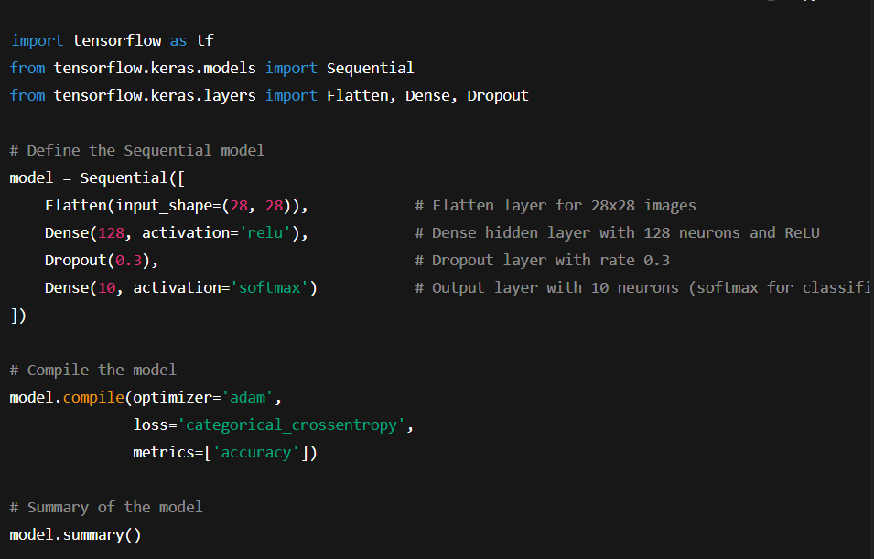
Explanation:
- Flatten: Converts each 28×28 image into a 1D vector of length 784.
- Dense(128, ReLU): A fully connected hidden layer with 128 neurons using ReLU activation.
- Dropout(0.3): Prevents overfitting by randomly dropping 30% of the neurons during training.
- Dense(10, softmax): Outputs probabilities for the 10 digit classes.
- Adam optimizer & categorical crossentropy: Common choices for classification tasks with one-hot encoded labels.
If your labels are integers (not one-hot encoded), you should replace "categorical_crossentropy" with "sparse_categorical_crossentropy".

- Create a CNN model for grayscale images of shape (28,28,1) with: Conv2D layer with 32 filters, 3x3 kernel, ReLU; MaxPooling2D with pool size 2x2; Conv2D layer with 64 filters, 3x3 kernel, ReLU; Flatten and Dense layer with 128 neurons, ReLU; Output Dense layer with 10 neurons, softmax.

import tensorflow as tf
from tensorflow.keras.models import Sequential
from tensorflow.keras.layers import Conv2D, MaxPooling2D, Flatten, Dense

# Define the CNN model
model = Sequential([
Conv2D(32, (3,3), activation='relu', input_shape=(28,28,1)), # Conv2D with 32 filters
MaxPooling2D(pool_size=(2,2)), # MaxPooling with 2x2 window
Conv2D(64, (3,3), activation='relu'), # Conv2D with 64 filters
Flatten(), # Flatten layer
Dense(128, activation='relu'), # Dense hidden layer with 128 neurons
Dense(10, activation='softmax') # Output layer with 10 neurons
])
# Compile the model
model.compile(optimizer='adam',
loss='categorical_crossentropy',
metrics=['accuracy'])
# Model summary
model.summary()

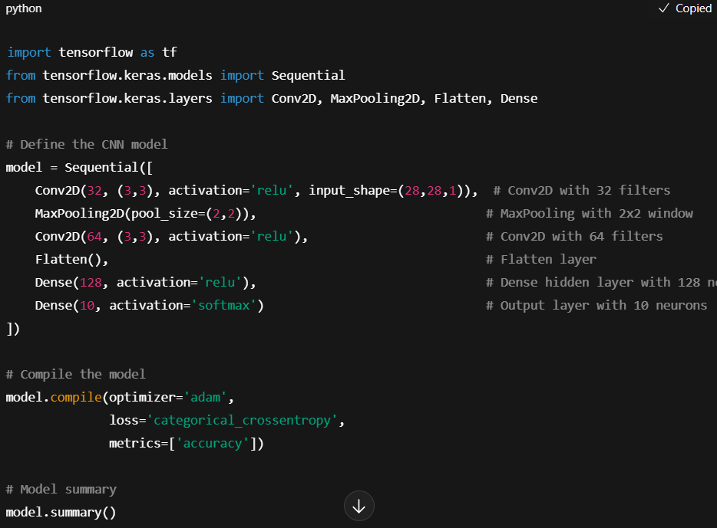
Explanation:
- Conv2D(32, 3×3, ReLU) → Learns 32 feature maps using 3×3 filters.
- MaxPooling2D(2×2) → Reduces spatial dimensions by taking the max value in each 2×2 region.
- Conv2D(64, 3×3, ReLU) → Learns 64 deeper feature maps.
- Flatten → Converts 2D feature maps into a 1D vector for the dense layers.
- Dense(128, ReLU) → Fully connected layer with 128 neurons.
- Dense(10, softmax) → Outputs class probabilities for 10 digits.

- Given a pre-trained Sequential model, add a new Dense layer of 64 neurons before the output and compile the model.

from tensorflow.keras.models import Sequential
from tensorflow.keras.layers import Dense

# Assume 'model' is your pre-trained Sequential model
# Get all layers except the output layer
layers = model.layers[:-1]

# Create a new Sequential model
new_model = Sequential()

# Add all previous layers except the old output layer
for layer in layers:
new_model.add(layer)

# Add new Dense layer with 64 neurons
new_model.add(Dense(64, activation='relu'))

# Add the old output layer back
new_model.add(model.layers[-1])

# Compile the updated model
new_model.compile(optimizer='adam',
loss='categorical_crossentropy',
metrics=['accuracy'])

# Summary of the new model
new_model.summary()

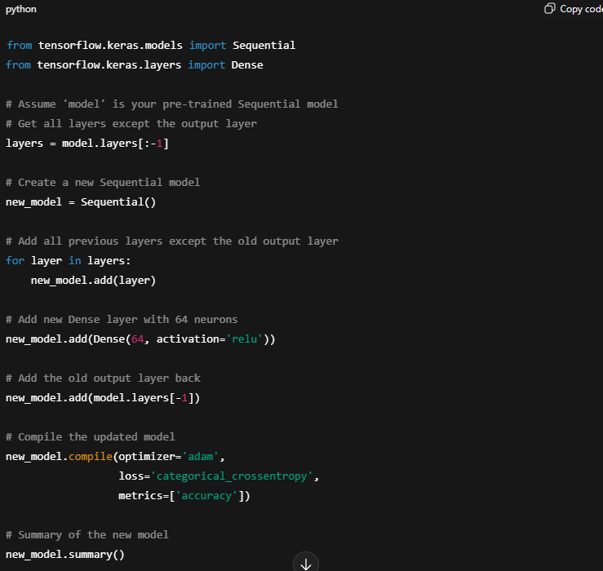

Explanation:
- We remove the output layer temporarily.
- Add a Dense(64, ReLU) layer before it.
- Attach the original output layer back.
- Compile the model again so it’s ready for training.

- Explain in code comments the difference between using sigmoid vs softmax for the output layer. Then implement an example with 3-class classification.

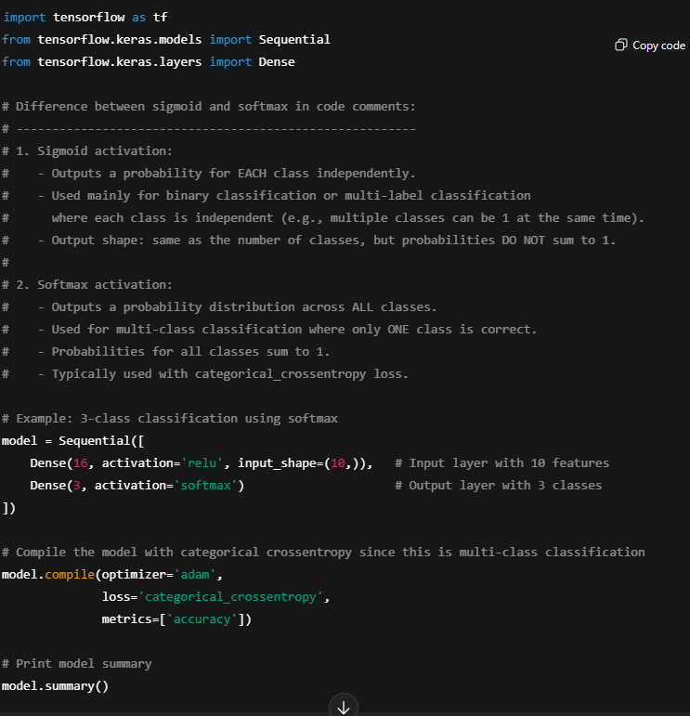

Summary
- Use sigmoid if you have binary or multi-label classification (each class is independent).
- Use softmax if you have multi-class classification with only one correct class per sample.

import tensorflow as tf
from tensorflow.keras.models import Sequential
from tensorflow.keras.layers import Dense

# Difference between sigmoid and softmax in code comments:
# --------------------------------------------------------
# 1. Sigmoid activation:
# - Outputs a probability for EACH class independently.
# - Used mainly for binary classification or multi-label classification
# where each class is independent (e.g., multiple classes can be 1 at the same time).
# - Output shape: same as the number of classes, but probabilities DO NOT sum to 1.
#
# 2. Softmax activation:
# - Outputs a probability distribution across ALL classes.
# - Used for multi-class classification where only ONE class is correct.
# - Probabilities for all classes sum to 1.
# - Typically used with categorical_crossentropy loss.

# Example: 3-class classification using softmax
model = Sequential([
Dense(16, activation='relu', input_shape=(10,)), # Input layer with 10 features
Dense(3, activation='softmax') # Output layer with 3 classes
])

# Compile the model with categorical crossentropy since this is multi-class classification
model.compile(optimizer='adam',
loss='categorical_crossentropy',
metrics=['accuracy'])

# Print model summary
model.summary()

- Create a functional API model that takes two inputs: Input1 of shape (32,) and Input2 of shape (32,). Concatenate them, pass through a Dense layer of 64 neurons, then output a single neuron with sigmoid activation.

import tensorflow as tf
from tensorflow.keras.layers import Input, Dense, Concatenate
from tensorflow.keras.models import Model

# Define two separate inputs
input1 = Input(shape=(32,))
input2 = Input(shape=(32,))

# Concatenate the inputs
merged = Concatenate()([input1, input2])

# Pass through a Dense layer with 64 neurons and ReLU activation
hidden = Dense(64, activation='relu')(merged)

# Output layer with a single neuron and sigmoid activation
output = Dense(1, activation='sigmoid')(hidden)

# Create the Functional model
model = Model(inputs=[input1, input2], outputs=output)

# Compile the model
model.compile(optimizer='adam',
loss='binary_crossentropy',
metrics=['accuracy'])

# Model summary
model.summary()

Explanation
- Input layers: Two separate inputs of shape (32,) each.
- Concatenate: Joins the two input vectors into a single tensor.
- Dense(64, ReLU): Fully connected layer with 64 neurons.
- Dense(1, sigmoid): Produces a single output value between 0 and 1 (binary classification).
- Functional API: Provides more flexibility than Sequential, perfect for multi-input/multi-output models.

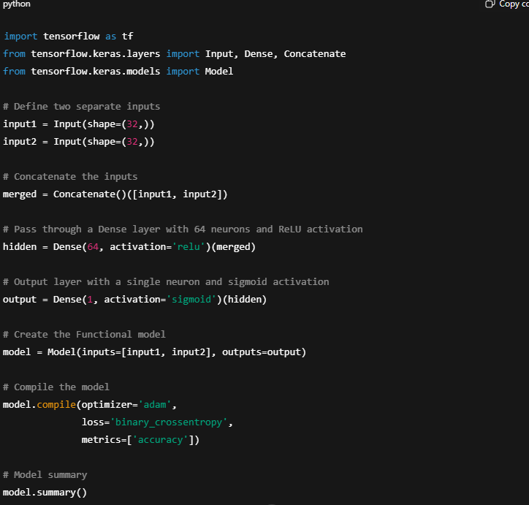

- Load the CIFAR-10 dataset, normalize images to range 0–1, and one-hot encode the labels.

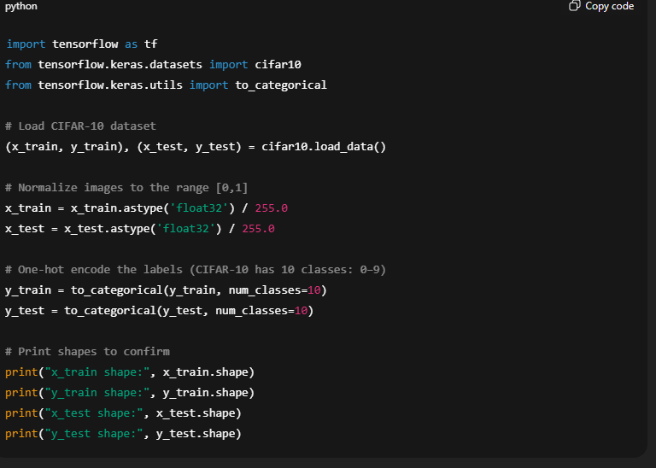

import tensorflow as tf
from tensorflow.keras.datasets import cifar10
from tensorflow.keras.utils import to_categorical

# Load CIFAR-10 dataset
(x_train, y_train), (x_test, y_test) = cifar10.load_data()

# Normalize images to the range [0,1]
x_train = x_train.astype('float32') / 255.0
x_test = x_test.astype('float32') / 255.0

# One-hot encode the labels (CIFAR-10 has 10 classes: 0–9)
y_train = to_categorical(y_train, num_classes=10)
y_test = to_categorical(y_test, num_classes=10)

# Print shapes to confirm
print("x_train shape:", x_train.shape)
print("y_train shape:", y_train.shape)
print("x_test shape:", x_test.shape)
print("y_test shape:", y_test.shape)

Explanation:
- cifar10.load_data(): Loads training (50,000 images) and test (10,000 images) sets.
- Normalization: Dividing by 255.0 scales pixel values from [0,255] to [0,1], which helps training stability.
- One-hot encoding: Converts class labels like 3 → [0,0,0,1,0,0,0,0,0,0].

- Given a dataset X of shape (1000, 28, 28), reshape it appropriately for a CNN input.

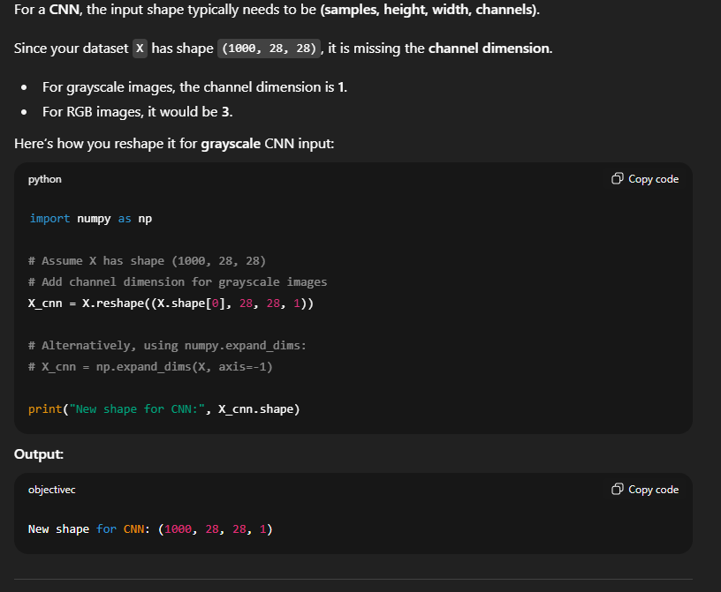

- Write code to split a dataset into 70% training, 15% validation, and 15% testing using sklearn.

from sklearn.model_selection import train_test_split
import numpy as np

# Example dataset
X = np.random.rand(1000, 20) # 1000 samples, 20 features
y = np.random.randint(0, 2, 1000) # Binary labels (0 or 1)

# Step 1: Split into 70% training and 30% temp (val+test)
X_train, X_temp, y_train, y_temp = train_test_split(
X, y, test_size=0.3, random_state=42, stratify=y
)

# Step 2: Split temp into 15% validation and 15% testing
# 15% of total = 15/30 = 0.5 of temp set
X_val, X_test, y_val, y_test = train_test_split(
X_temp, y_temp, test_size=0.5, random_state=42, stratify=y_temp
)

# Print shapes to verify
print("Train set:", X_train.shape, y_train.shape)
print("Validation set:", X_val.shape, y_val.shape)
print("Test set:", X_test.shape, y_test.shape)

Explanation:
- First split: 70% training, 30% remaining for val+test.
- Second split: The remaining 30% is split equally → 15% validation, 15% test.
- stratify=y ensures class balance in each split for classification tasks.

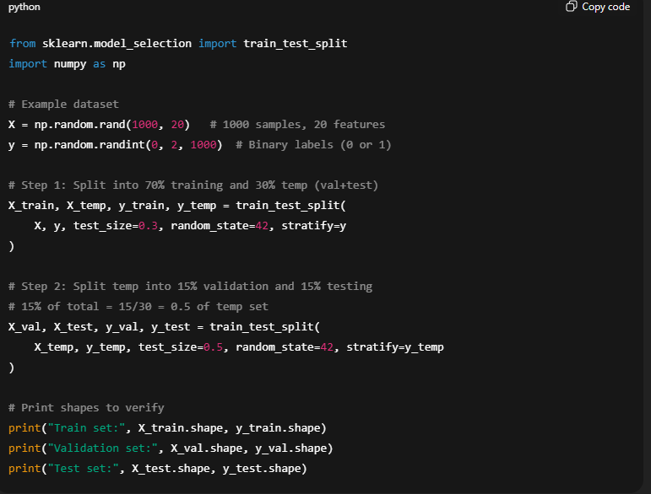

- Apply data augmentation on image data using ImageDataGenerator with horizontal flips, rotations of 15 degrees, and width/height shifts of 0.1.

from tensorflow.keras.preprocessing.image import ImageDataGenerator

# Create an ImageDataGenerator with augmentation settings
datagen = ImageDataGenerator(
rotation_range=15, # Rotate images by up to 15 degrees
width_shift_range=0.1, # Shift width by up to 10%
height_shift_range=0.1, # Shift height by up to 10%
horizontal_flip=True # Flip images horizontally
)

# Example: Assume X_train is your training images (shape: (num_samples, height, width, channels))
# Fit the generator to the data if necessary (e.g., for featurewise normalization)
# datagen.fit(X_train)

# Generate augmented images in batches
batch_size = 32
augmented_data = datagen.flow(X_train, y_train, batch_size=batch_size)

# Now 'augmented_data' can be used in model.fit() for training
# model.fit(augmented_data, epochs=10, validation_data=(X_val, y_val))
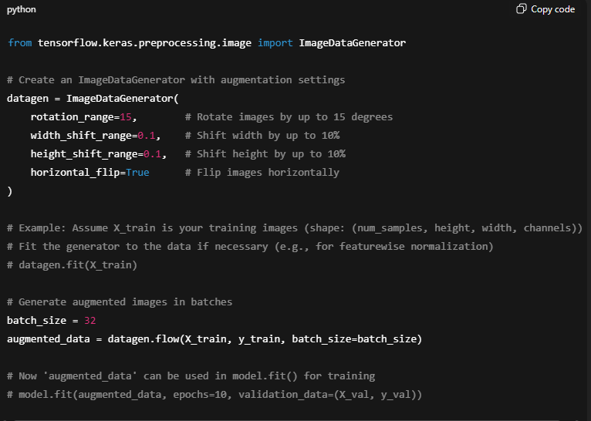

Explanation
- rotation_range=15 → Randomly rotates images within ±15 degrees.
- width_shift_range=0.1, height_shift_range=0.1 → Randomly shifts image width/height by 10%.
- horizontal_flip=True → Randomly flips images horizontally.
- datagen.flow() → Creates a generator that yields augmented batches of images for training.

- Visualize 5 random images from your dataset with their corresponding labels using matplotlib.

import matplotlib.pyplot as plt
import numpy as np

# Example: Assume X_train (images) and y_train (labels) are already defined
# X_train shape: (num_samples, height, width, channels)
# y_train shape: (num_samples,) or one-hot encoded

# Select 5 random indices
random_indices = np.random.choice(X_train.shape[0], 5, replace=False)

# Create a figure
plt.figure(figsize=(10, 2))

for i, idx in enumerate(random_indices):
plt.subplot(1, 5, i+1)
image = X_train[idx]

# If images are grayscale, remove the channel dimension for display
if image.shape[-1] == 1:
image = image.squeeze()

plt.imshow(image, cmap='gray' if len(image.shape) == 2 else None)
plt.title(f"Label: {y_train[idx] if y_train.ndim == 1 else np.argmax(y_train[idx])}")
plt.axis('off')

plt.tight_layout()
plt.show()

Explanation
- np.random.choice selects 5 random samples without replacement.
- plt.imshow displays each image.
- If labels are one-hot encoded, we use np.argmax to get the class index.
- Works for both grayscale (1 channel) and RGB (3 channels) images.

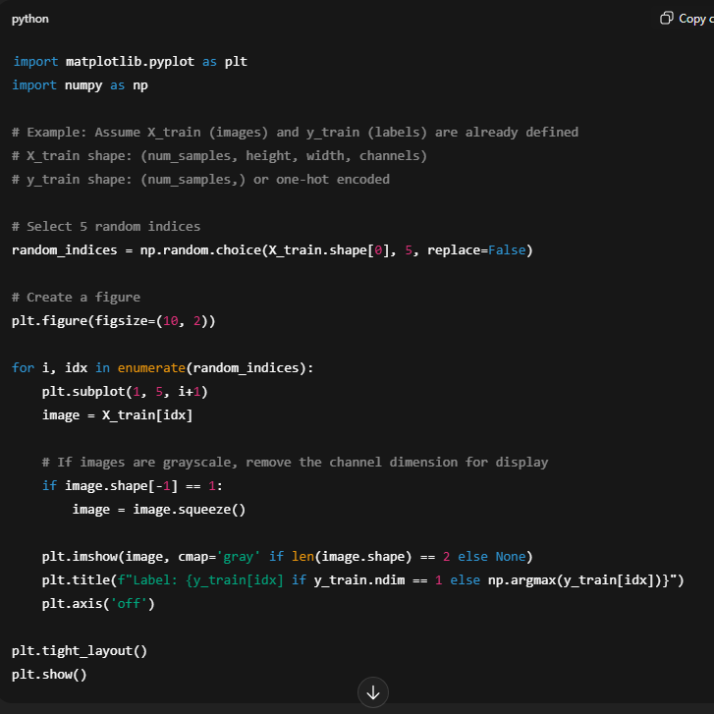

- Train a Sequential model on training data for 10 epochs, using validation data for evaluation. Include EarlyStopping if validation loss doesn’t improve for 3 epochs.

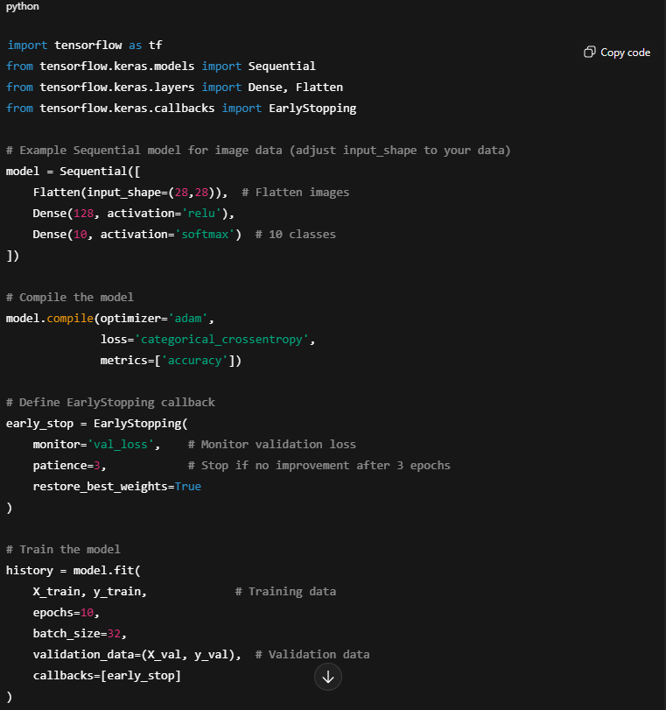
Explanation
- EarlyStopping monitors val_loss and stops training if it doesn’t improve for patience epochs.
- restore_best_weights=True ensures the model retains the weights from the epoch with the best validation loss.
- history object stores training/validation loss and accuracy per epoch for plotting later if needed.

import tensorflow as tf
from tensorflow.keras.models import Sequential
from tensorflow.keras.layers import Dense, Flatten
from tensorflow.keras.callbacks import EarlyStopping

# Example Sequential model for image data (adjust input_shape to your data)
model = Sequential([
Flatten(input_shape=(28,28)), # Flatten images
Dense(128, activation='relu'),
Dense(10, activation='softmax') # 10 classes
])

# Compile the model
model.compile(optimizer='adam',
loss='categorical_crossentropy',
metrics=['accuracy'])

# Define EarlyStopping callback
early_stop = EarlyStopping(
monitor='val_loss', # Monitor validation loss
patience=3, # Stop if no improvement after 3 epochs
restore_best_weights=True
)

# Train the model
history = model.fit(
X_train, y_train, # Training data
epochs=10,
batch_size=32,
validation_data=(X_val, y_val), # Validation data
callbacks=[early_stop]
)

- Implement ModelCheckpoint to save the best model during training based on validation accuracy.
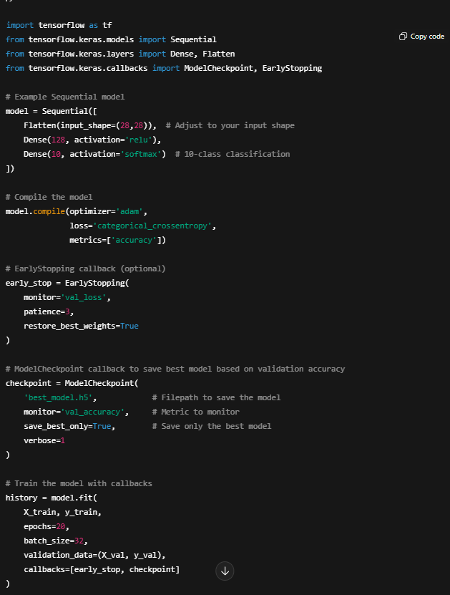
Explanation
- ModelCheckpoint monitors val_accuracy and saves the model only when the validation accuracy improves.
- save_best_only=True ensures you don’t overwrite the best weights with worse ones.
- You can later load the saved model with:
from tensorflow.keras.models import load_model
best_model = load_model('best_model.h5')

import tensorflow as tf
from tensorflow.keras.models import Sequential
from tensorflow.keras.layers import Dense, Flatten
from tensorflow.keras.callbacks import ModelCheckpoint, EarlyStopping

# Example Sequential model
model = Sequential([
Flatten(input_shape=(28,28)), # Adjust to your input shape
Dense(128, activation='relu'),
Dense(10, activation='softmax') # 10-class classification
])

# Compile the model
model.compile(optimizer='adam',
loss='categorical_crossentropy',
metrics=['accuracy'])

# EarlyStopping callback (optional)
early_stop = EarlyStopping(
monitor='val_loss',
patience=3,
restore_best_weights=True
)

# ModelCheckpoint callback to save best model based on validation accuracy
checkpoint = ModelCheckpoint(
'best_model.h5', # Filepath to save the model
monitor='val_accuracy', # Metric to monitor
save_best_only=True, # Save only the best model
verbose=1
)

# Train the model with callbacks
history = model.fit(
X_train, y_train,
epochs=20,
batch_size=32,
validation_data=(X_val, y_val),
callbacks=[early_stop, checkpoint]
)

- Plot the training and validation loss curves for a trained model and explain how to identify overfitting from the graph.

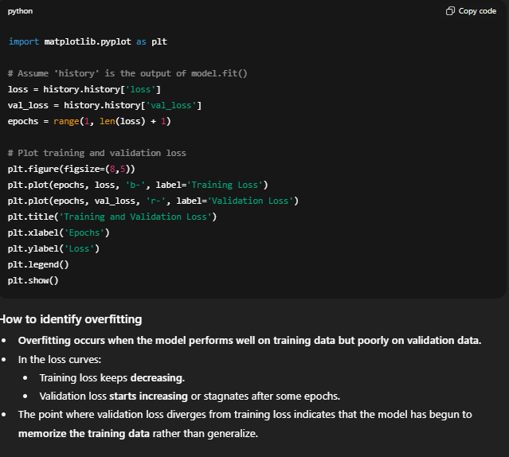
import matplotlib.pyplot as plt

# Assume 'history' is the output of model.fit()
loss = history.history['loss']
val_loss = history.history['val_loss']
epochs = range(1, len(loss) + 1)

# Plot training and validation loss
plt.figure(figsize=(8,5))
plt.plot(epochs, loss, 'b-', label='Training Loss')
plt.plot(epochs, val_loss, 'r-', label='Validation Loss')
plt.title('Training and Validation Loss')
plt.xlabel('Epochs')
plt.ylabel('Loss')
plt.legend()
plt.show()

- Evaluate a trained model on test data and print both loss and accuracy.

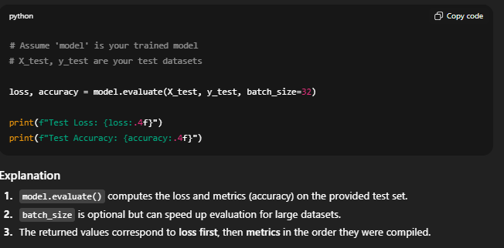

# Assume 'model' is your trained model
# X_test, y_test are your test datasets

loss, accuracy = model.evaluate(X_test, y_test, batch_size=32)

print(f"Test Loss: {loss:.4f}")
print(f"Test Accuracy: {accuracy:.4f}")

- Given training and validation loss arrays: train_loss = [0.8, 0.5, 0.3, 0.2] and val_loss = [0.9, 0.6, 0.4, 0.5], write code to detect overfitting and explain why it occurs.
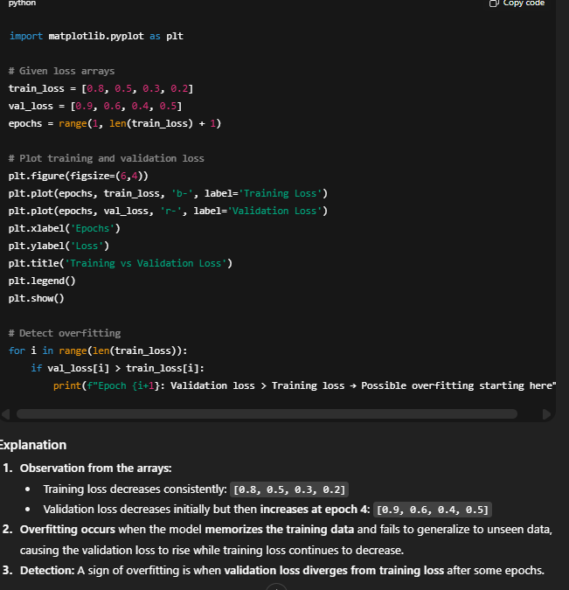

import matplotlib.pyplot as plt

# Given loss arrays
train_loss = [0.8, 0.5, 0.3, 0.2]
val_loss = [0.9, 0.6, 0.4, 0.5]
epochs = range(1, len(train_loss) + 1)

# Plot training and validation loss
plt.figure(figsize=(6,4))
plt.plot(epochs, train_loss, 'b-', label='Training Loss')
plt.plot(epochs, val_loss, 'r-', label='Validation Loss')
plt.xlabel('Epochs')
plt.ylabel('Loss')
plt.title('Training vs Validation Loss')
plt.legend()
plt.show()

# Detect overfitting
for i in range(len(train_loss)):
if val_loss[i] > train_loss[i]:
print(f"Epoch {i+1}: Validation loss > Training loss → Possible overfitting starting here")

- Given a pre-trained CNN, write code to freeze all layers except the last Dense layer, then compile it for fine-tuning.

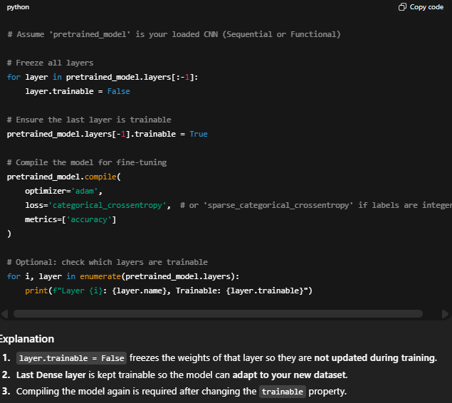
# Assume 'pretrained_model' is your loaded CNN (Sequential or Functional)

# Freeze all layers
for layer in pretrained_model.layers[:-1]:
layer.trainable = False

# Ensure the last layer is trainable
pretrained_model.layers[-1].trainable = True

# Compile the model for fine-tuning
pretrained_model.compile(
optimizer='adam',
loss='categorical_crossentropy', # or 'sparse_categorical_crossentropy' if labels are integers
metrics=['accuracy']
)

# Optional: check which layers are trainable
for i, layer in enumerate(pretrained_model.layers):
print(f"Layer {i}: {layer.name}, Trainable: {layer.trainable}")
- Extract the output of an intermediate layer (second Dense layer) for a single input sample using Keras functional API.

import tensorflow as tf
from tensorflow.keras.models import Model
from tensorflow.keras.layers import Input, Dense, Flatten
import numpy as np

# Example model
inputs = Input(shape=(28,28))
x = Flatten()(inputs)
x = Dense(128, activation='relu', name='dense_1')(x)
x = Dense(64, activation='relu', name='dense_2')(x) # Second Dense layer
outputs = Dense(10, activation='softmax')(x)

model = Model(inputs=inputs, outputs=outputs)

# Assume single input sample of shape (28,28)
sample_input = np.random.rand(1,28,28).astype('float32')

# Create a new model that outputs the second Dense layer
intermediate_layer_model = Model(inputs=model.input,
outputs=model.get_layer('dense_2').output)

# Get the output of the intermediate layer
intermediate_output = intermediate_layer_model.predict(sample_input)

print("Intermediate layer output shape:", intermediate_output.shape)
print("Intermediate layer output values:", intermediate_output)

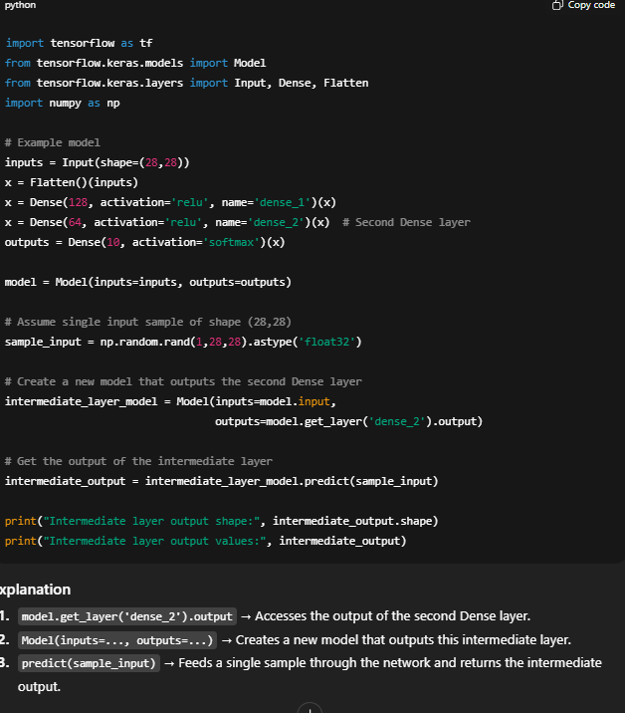

- Implement a custom loss function for mean squared error and use it in compiling a model.

import tensorflow as tf
from tensorflow.keras.models import Sequential
from tensorflow.keras.layers import Dense, Flatten

# Define custom MSE loss function
def custom_mse(y_true, y_pred):
# Computes mean squared error
return tf.reduce_mean(tf.square(y_true - y_pred))

# Example Sequential model
model = Sequential([
Flatten(input_shape=(28,28)),
Dense(128, activation='relu'),
Dense(10, activation='linear') # Using linear output for regression example
])

# Compile the model with the custom loss
model.compile(optimizer='adam',
loss=custom_mse,
metrics=['mse']) # You can also track MSE as a metric

# Print model summary
model.summary()
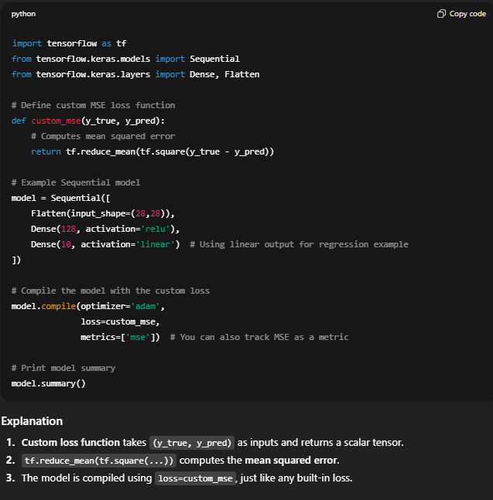
- Save a trained model to disk in both HDF5 and SavedModel formats. Then write code to load it back.

import tensorflow as tf
from tensorflow.keras.models import Sequential
from tensorflow.keras.layers import Dense, Flatten

# Example model
model = Sequential([
Flatten(input_shape=(28,28)),
Dense(128, activation='relu'),
Dense(10, activation='softmax')
])

# Compile the model
model.compile(optimizer='adam',
loss='categorical_crossentropy',
metrics=['accuracy'])

# -----------------------------
# Save the model
# -----------------------------

# 1. HDF5 format
model.save('model.h5') # Saves entire model (architecture + weights + optimizer state)

# 2. TensorFlow SavedModel format
model.save('saved_model/my_model') # Directory containing the SavedModel

# -----------------------------
# Load the model back
# -----------------------------

# Load from HDF5
loaded_model_h5 = tf.keras.models.load_model('model.h5')

# Load from SavedModel
loaded_model_saved = tf.keras.models.load_model('saved_model/my_model')

# Verify by printing model summaries
print("Loaded model from HDF5:")
loaded_model_h5.summary()

print("\nLoaded model from SavedModel:")
loaded_model_saved.summary()

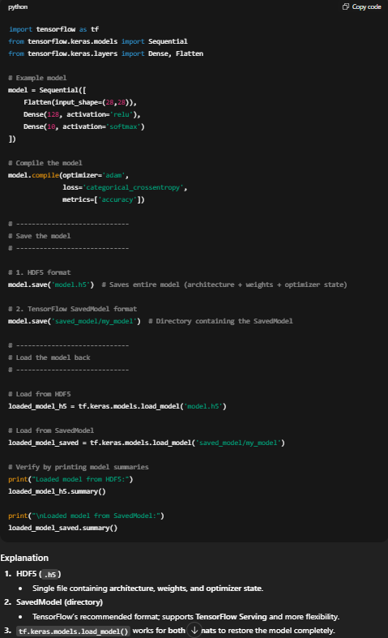

- Apply softmax manually on the tensor logits = [2.0, 1.0, 0.1] using numpy and compare it with TensorFlow’s softmax output.

import numpy as np
import tensorflow as tf

# Given logits
logits = np.array([2.0, 1.0, 0.1])

# -------------------------------
# Manual softmax using NumPy
# -------------------------------
# Step 1: Shift logits for numerical stability
shifted_logits = logits - np.max(logits)
exp_logits = np.exp(shifted_logits)
softmax_manual = exp_logits / np.sum(exp_logits)

print("Manual softmax:", softmax_manual)

# -------------------------------
# Softmax using TensorFlow
# -------------------------------
logits_tf = tf.constant(logits, dtype=tf.float32)
softmax_tf = tf.nn.softmax(logits_tf).numpy()

print("TensorFlow softmax:", softmax_tf)

# -------------------------------
# Check if close
print("Are the outputs close?", np.allclose(softmax_manual, softmax_tf))

